Maureen Martin Ferris
June 2025 | maureen.ferris@outlook.com.au
AI & Genealogy
Guide for using AI with your family history

AI serves as a valuable research companion, offering powerful tools to support, assist and streamline your work.
Below are some ways it can help you.
The all important first step is to make sure you give the prompt the right command, so you get what you information you need. – DO YOUR HOMEWORK

Item |  | Page
1 | AI Bots | 2
2 | Searching Historical Records | 4
3 | Optical Character Recognition (OCR) | 4
4 | DNA Analysis & Family Tree Building | 4
5 | Predictive Ancestry Insights | 4
6 | Translations of Language | 4
7 | Image Restoration, Enhancement, Sharpen & Facial Recognition | 4
8 | Newspaper & Archive Mining | 6
9 | AI Chatbots for Genealogy Assistance | 6
10 | Genealogy AI Communities | 6
11 | Cross- Referencing Historical Data | 6
12 | Language Deciphering or Script/Cursive writing | 6
13 | Convert text into tables with columns | 7
14 | AI re-write your information/narrative as a historian | 8
15 | Suggestions for book title, document, poster & family reunion | 12
16 | YouTube videos AI and Genealogy Research | 13

Verify all sources carefully, treating provided information as a reference rather than absolute fact. Use AI as a tool for guidance, but ensure all details are independently proven through reliable evidence.
IMPORTANT: Limit personal information.

AI Bot | Free Tier | Free Tier Limits | Paid Plans & Cost | Special Requirements | Access URL | Key Features
ChatGPT (OpenAI) | ✅ Yes | Access to GPT-3.5 and limited GPT-4o usage (approx. 40 messages per 3 hours). Includes basic voice mode, image generation, file uploads, and web browsing. | Plus: $20/month – Access to GPT-4o with extended limits, advanced voice mode, and priority access. Pro: $200/month – Higher usage limits and additional features. | None | chat.openai.com | Text and image generation, voice interaction, code assistance, data analysis, web browsing.
DeepSeek | ✅ Yes | Free access to DeepSeek-V3 model via web and mobile apps. API access includes 5 million tokens/month for the Lite model. | API pricing starts at $0.014 per 1M tokens for deepseek-chat and $0.14 per 1M tokens for deepseek-reasoner. | None | deepseek.com | Text generation, code assistance, scientific research support, open-source model.
Grok (xAI) | ✅ Yes | 10 messages every 2 hours; up to 3 image analyses and 4 image generations per day. | SuperGrok: $30/month – Increased limits and additional features. X Premium: $8/month; Premium+: $14/month – Higher usage caps. | Requires an X (formerly Twitter) account that is at least 7 days old and linked to a phone number. | grok.com | Conversational AI with humor, real-time information, image generation.
Gemini (Google) | ✅ Yes | Access to Gemini 1.5 Flash model with 32k token context window. Limited requests per minute and per day. | AI Pro: $19.99/month – Access to Gemini 2.5 Pro, Deep Research, 1M token context window, and additional storage. AI Ultra: $249.99/month – Access to advanced models and features. | Requires a Google account; some features may be limited based on region. | gemini.google.com | Text and image generation, integration with Google Workspace, code execution, deep research tools.
Claude (Anthropic) | ✅ Yes | Limited usage with access to Claude's capabilities. | Claude Pro: $20/month – Increased usage limits, priority access during high demand, and early access to new features. | None | claude.ai | Text generation, code assistance, data analysis, neutral and helpful tone suitable for business use.
Microsoft Copilot | ✅ Yes | Access to GPT-4 and GPT-4 Turbo during non-peak times; 15 image generation boosts per day; voice interaction with unlimited usage. | Copilot Pro: $20/month – Priority access to GPT-4 and GPT-4 Turbo during peak times, 100 image generation boosts per day, integration with Microsoft 365 apps. | Requires a Microsoft account; additional features available with Microsoft 365 subscription. | copilot.microsoft.com | Text and image generation, voice interaction, code assistance, integration with Microsoft 365 apps, Windows 11 integration.

While AI chatbots like ChatGPT, Grok, Gemini, Claude, DeepSeek, and Microsoft Copilot offer powerful tools for communication, productivity, and creativity, they also come with significant risks and limitations. Here's a breakdown of key concerns to be aware of:

Tips for Safe and Responsible AI Use
- Verify Information: Always cross-check AI-generated content with reliable sources.
- Limit Sharing Personal Data: Avoid inputting sensitive information into AI chatbots.
- Be Aware of Biases: Recognize that AI outputs may reflect societal biases.
- Maintain Human Oversight: Use AI as a tool to augment, not replace, human judgment.
- Educate Yourself: Stay informed about AI capabilities and limitations.
AI chatbots are powerful tools, but they are not infallible. Understanding their limitations and potential risks is crucial for safe and effective use. Always approach AI-generated content with a critical eye and prioritize human oversight in decision-making processes.

2. Searching Historical Records
AI-powered search engines can help you sift through digitized historical records, including census data, birth/death certificates, immigration records, and newspaper archives. Many genealogy databases use AI to suggest potential relatives based on historical patterns.

3. Optical Character Recognition (OCR)
If you have old family documents, letters, or handwritten records, AI-driven OCR can help convert them into searchable digital text, making it easier to analyse names, dates, and places.

4. DNA Analysis & Family Tree Building
Genealogy services use AI to analyse DNA matches and suggest potential family connections. AI can also assist in building visual family trees by organising relationships based on historical records and DNA data.

5. Predictive Ancestry Insights
Some AI algorithms can analyse migration patterns and surname distributions to provide insights into where your ancestors may have lived or travelled.

6. Translations Language
If your genealogy research includes records in different languages, AI-powered translation tools can help decode old documents, making foreign-language texts more accessible.

7. Image Restoration, Enhancement, Sharpen & Facial Recognition
AI can restore old family photos by enhancing faded images or even using facial recognition to identify relatives across different generations. It can also move objects from an image – Here are some examples
 | >Please remove the person & enhance this image  
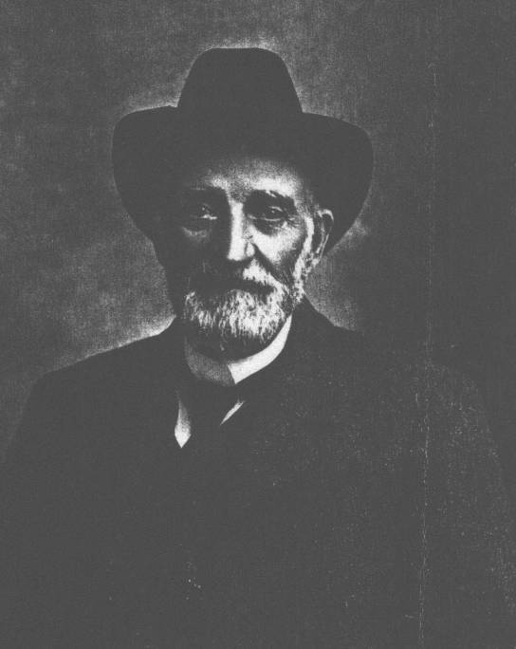 | 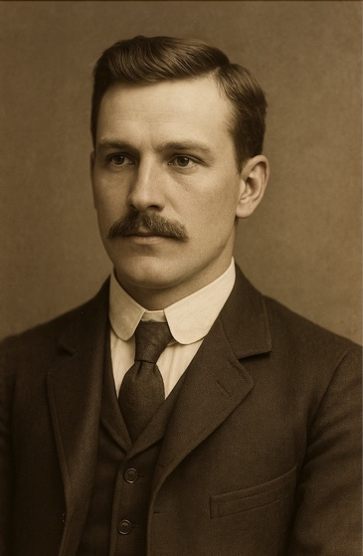
>This is a photograph of my g.g. grandfather can you show me what he would look like at the age of 30 years
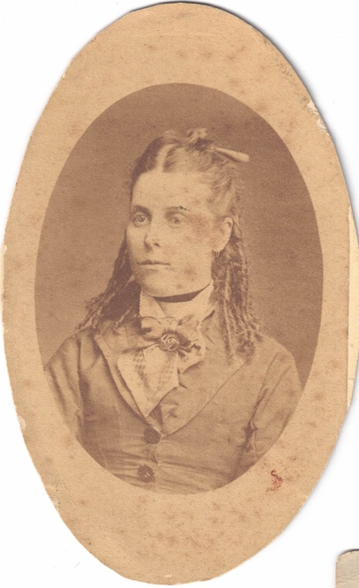 | 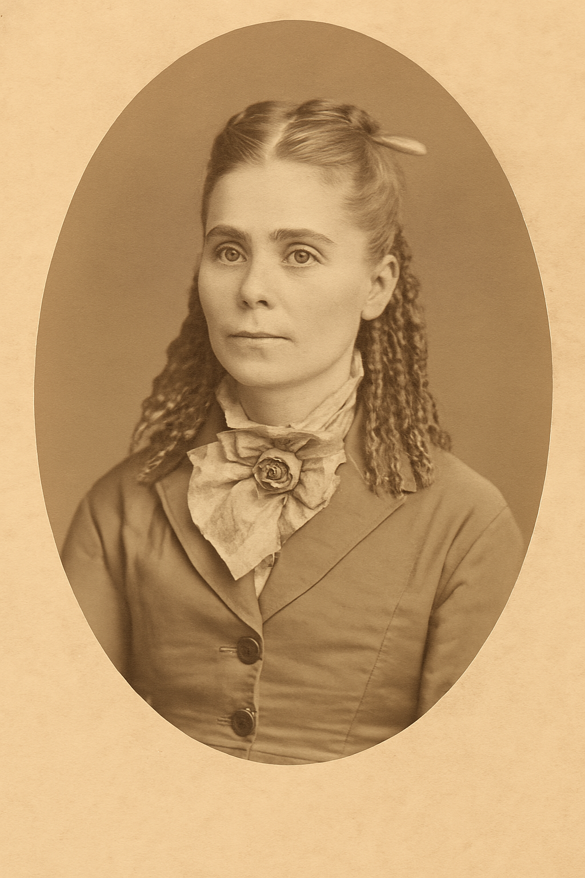
>Please make this old photograph of my great grandmother better and take our any blemishes
(clothes look good, but the face in NOT spot on)
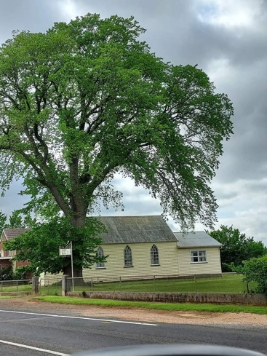 | 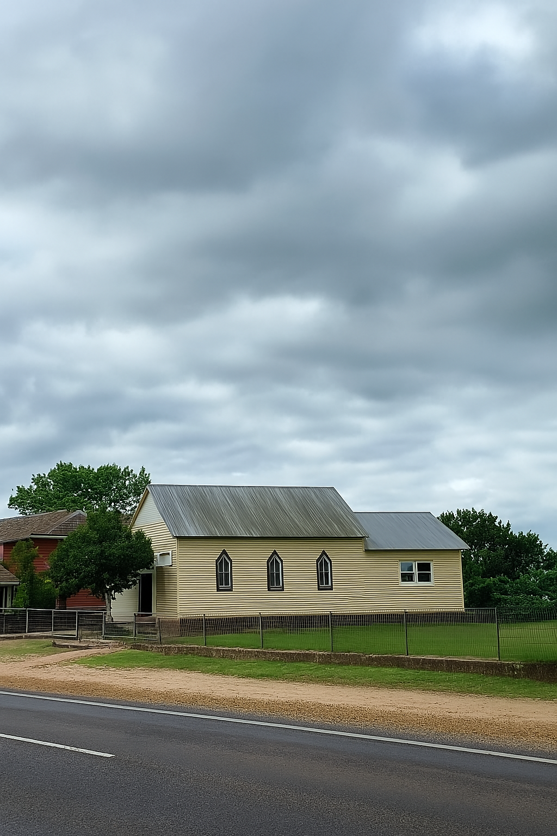
Me>Please remove the green tree on the left of this photograph, make it look realistic

8. Newspaper & Archive Mining
AI can scan through old newspapers and archives much faster than manual searching, helping you find mentions of family members in historical articles, obituaries, or event records.

9. AI Chatbots for Genealogy Assistance
Some genealogy platforms use AI chatbots to help answer research questions, suggest records to explore, and guide your search based on common ancestry queries.

10. Genealogy AI Communities
There are AI-assisted genealogy forums where people collaborate on family history research, using machine learning to cross-reference trees and match potential relatives.

11. Cross-Referencing Historical Data
AI can help compare records from different sources to verify accuracy, ensuring that the people and events you uncover are correctly linked.

12. Language Deciphering or Script/Cursive writing
AI can analyse cursive or handwritten text and convert it into digital text. This process, known as handwriting recognition, uses algorithms to interpret the shapes and strokes of letters. While AI is quite good at recognizing neat handwriting, accuracy can decrease with messy or stylized script.
For historical documents or difficult-to-read cursive, AI can assist by providing a rough transcription, which can then be manually corrected for accuracy. Some tools even allow for training models on specific handwriting styles to improve results over time.
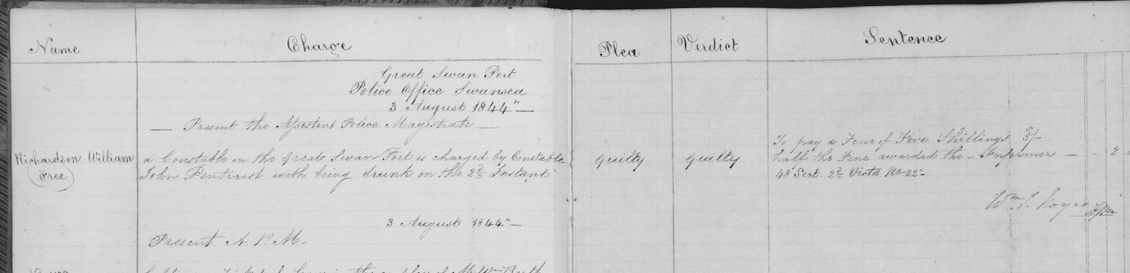
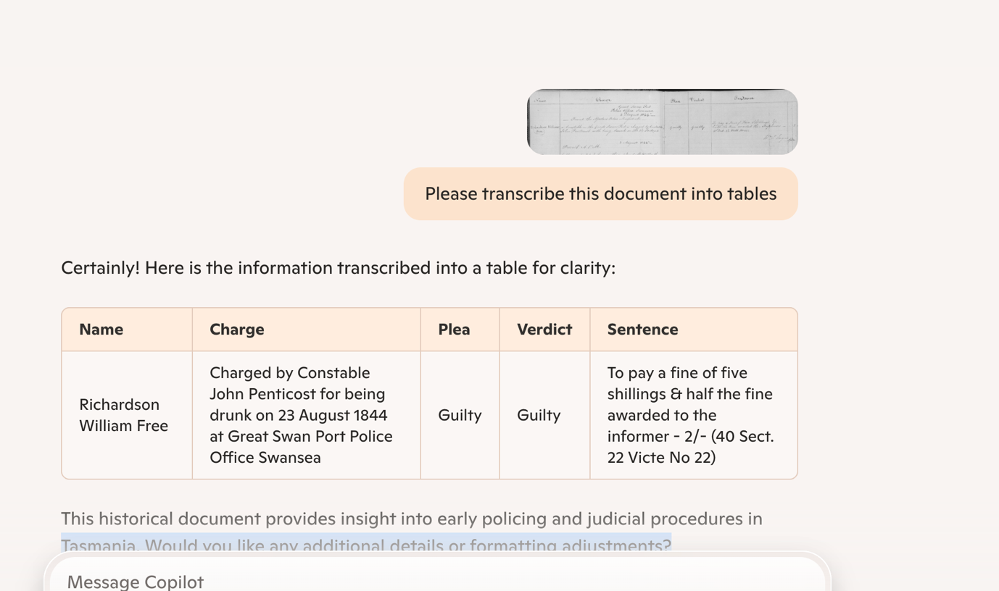

13. Convert text into tables with columns

Me> Please turn this information into a tables with columns relevant to the subject

e.g. SPRING BAY -- ST. LEONARDS Progress Association . -- Orford . Chairman , H. V. Judge . Secretary , Miss F. Rudd . RSL . -- Buckland Sub - Branch . President : G. C. Gadd . Secretary : C. Clinten . Treasurer : K. McConnon . Hospital Auxiliary . -- Secretary : Mrs. H. Thompson . Country Women 's Association . -- Orford Branch . Secretary , Miss F. Rudd . Buckland Branch : Secretary , Mrs. Cornish . Triabunna Branch : Secretary , Mrs. B. Bradley , Cricket .
AI<

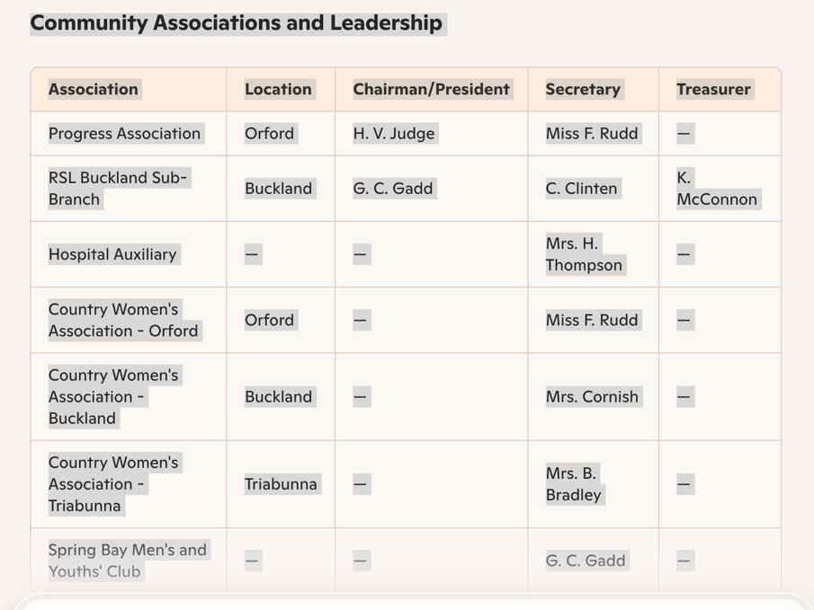

14. AI re-write your information as a historian – thus improving your writing skills
AI can help refine and re-write your family history, giving it a polished, professional appearance. It can also incorporate details about the life, times, and place in which your ancestor lived, adding depth to your narrative.
To make the most of AI’s capabilities, start by outlining what you want to say about your ancestor—include dates, places, events, and any significant details or events. AI can help expand on these by researching historical events and providing relevant context. Always request sources for any additional information it finds to ensure accuracy.
Note: Be sure to ask it to use Australian grammar to maintain consistency in spelling and style.
e.g.
Me> Please re-write this narrative as a historian, including dates, places, events and information from the internet, please use Australian grammar to maintain consistency in spelling and style.
George Smith was born in Fermanagh Ireland circa 1799, he came to Van Diemen’s Land as a convict on the ship ‘Westmoreland’ in 1821. His time as a convict was not very eventful and he committed no crimes, he was 5 feet 6 ins tall, had brown eye and hair and a anchor tattoo on his left arm. George arrived under the assignment system and was assigned to the Muster Master department, writing up convict records. In 1835 he married Miss Phoebe Wilde a free settler in St David’s church in Hobart. Phoebe was the only daughter of Joseph & Edith Wilde. George and Pheobe had 5 children between 1836-1848, John, Mary, Phoebe, George and James. By 1840 the family moved to Adelaide, South Australia where they ran a public house called the ‘Black Swan’. Sadly in April 1850 Pheobe drowned while crossing from Adelaide to South Australia on the ship ‘Lady Denison’. George lived on in Adelaide died as a result of an accident while driving a cart loaded with barrels of alcohol in 1852.
AI< George Smith was born in County Fermanagh, Ireland, circa 1799. In 1821, he was transported to Van Diemen’s Land aboard the convict ship Westmoreland. His convict record indicates a relatively uneventful period of servitude, with no recorded infractions. Smith was described as 5 feet 6 inches tall, with brown eyes and hair, and bore an anchor tattoo on his left arm.
Upon arrival, he was placed under the assignment system, which allocated convicts to work for private individuals or government departments. Smith was assigned to the Muster Master’s Department, where he was responsible for recording convict records—a role that suggests literacy and administrative competence.
In 1835, Smith married Phoebe Wilde, a free settler, at St David’s Church in Hobart. Phoebe was the only daughter of Joseph and Edith Wilde. The couple had five children between 1836 and 1848: John, Mary, Phoebe, George, and James.
By 1840, the Smith family relocated to Adelaide, South Australia, where they operated the Black Swan Inn, a public house situated on North Terrace. The establishment was well-known in the growing colony, providing accommodation and refreshments to travellers and locals alike.
Tragedy struck in April 1850, when Phoebe drowned while crossing from Adelaide to Hobart aboard the Lady Denison. The ship, launched in 1847, was lost at sea under mysterious circumstances, with wreckage later discovered along the Tasmanian coast.
Smith remained in Adelaide, but his life was cut short in 1852 when he suffered a fatal accident while driving a cart loaded with barrels of alcohol. The details surrounding his death remain sparse, but such incidents were not uncommon in colonial Australia, where transportation hazards posed significant risks.
- Would you like me to refine any sections further or add additional historical context?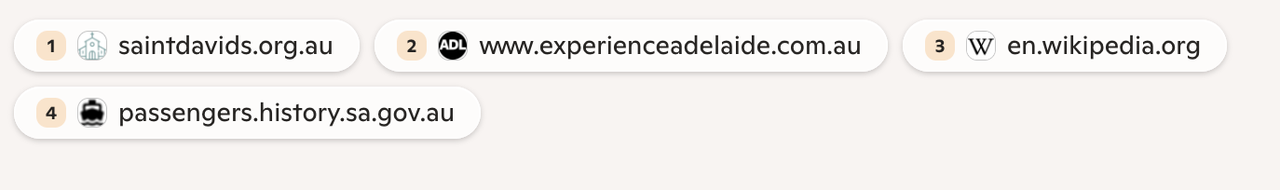
I then asked AI:
Me> Can you please incorporated information about Ireland between 1799-1821, including his journey to VDL and life as a convict in Van Diemen's Land between 1821-1845 and Adelaide between 1845-1852 please use Australian grammar to maintain consistency in spelling and style.
AI< Certainly! Here’s a refined historical narrative incorporating details about Ireland (1799-1821), George Smith’s journey to Van Diemen’s Land, his life as a convict (1821-1845), and his time in Adelaide (1845-1852).

AI wrote:

AI< George Smith: A Life Across Continents (1799-1852)

Life in Ireland (1799-1821)
George Smith was born in County Fermanagh, Ireland, circa 1799, during a period of significant social and political upheaval. Ireland was still reeling from the Irish Rebellion of 1798, a failed uprising against British rule that led to harsh reprisals. In 1801, the Act of Union merged Ireland with Great Britain, creating the United Kingdom of Great Britain and Ireland.
The early 19th century saw rapid population growth, with numbers rising from 5 million in 1800 to 6.8 million by 1821¹. However, economic hardship persisted, particularly for rural families. Many Irish people lived in small, thatched cottages, relying on subsistence farming, with potatoes as their staple food. Land ownership was concentrated among English landlords, leaving Irish tenants vulnerable to eviction and poverty.
Agrarian unrest was common, with secret societies such as the Ribbonmen resisting unfair rents and evictions. The British government responded with military enforcement, including the Peace Preservation Force, established in 1814 to quell disturbances¹.
For many Irish men, transportation to Van Diemen’s Land was a fate imposed for crimes ranging from theft to political dissent. Smith’s conviction and subsequent transportation in 1821 placed him among thousands of Irish convicts sent to Australia during this period.

Journey to Van Diemen’s Land (1821)
Smith was transported aboard the convict ship Westmoreland, which departed England in 1821. Convict voyages were harsh and overcrowded, with prisoners confined below deck for most of the journey. Ships often stopped at Tenerife or Rio de Janeiro for supplies before continuing to Hobart Town or Port Dalrymple².
Convicts endured poor sanitation, disease, and malnutrition, with outbreaks of dysentery and scurvy common. The journey could take four to six months, depending on weather conditions. Upon arrival, convicts were processed, assigned, or sent to penal settlements.

Life as a Convict in Van Diemen’s Land (1821-1845)
Van Diemen’s Land was a penal colony, receiving over 75,000 convicts between 1803 and 1853. Smith arrived under the assignment system, which placed convicts in government service or private employment. His literacy skills secured him a position in the Muster Master’s Department, where he recorded convict records.
Convicts were subject to strict discipline, with punishments including flogging, solitary confinement, and hard labour. However, those who demonstrated good behaviour could earn a Ticket of Leave, allowing them to work freely.
By the 1830s, Van Diemen’s Land had developed into a thriving colony, with Hobart and Launceston serving as major centres. However, the colony’s convict past led to social stigma, and free settlers often resented the penal system³.
In 1835, Smith married Phoebe Wilde, a free settler, at St David’s Church in Hobart. The couple had five children between 1836 and 1848: John, Mary, Phoebe, George, and James.

Life in Adelaide (1845-1852)
By 1845, Smith and his family relocated to Adelaide, South Australia, a free colony established in 1836. Unlike Van Diemen’s Land, Adelaide did not receive convicts, attracting free settlers seeking economic opportunities⁴.
The city was designed by Colonel William Light, featuring wide streets, parklands, and a structured layout. Early settlers engaged in agriculture, trade, and hospitality, with public houses like the Black Swan Inn serving as important social hubs.
Economic downturns in the 1840s led to high unemployment, with 642 houses vacant in 1842⁵. However, by the 1850s, Adelaide had stabilised, becoming a prosperous colony with mining, agriculture, and trade driving growth.
Tragedy struck in April 1850, when Phoebe drowned while crossing from Adelaide to Hobart aboard the Lady Denison. The ship, launched in 1847, was lost at sea under mysterious circumstances, with wreckage later discovered along the Tasmanian coast.
Smith remained in Adelaide, but his life was cut short in 1852 when he suffered a fatal accident while driving a cart loaded with barrels of alcohol. The details surrounding his death remain sparse, but such incidents were not uncommon in colonial Australia, where transportation hazards posed significant risks.
AI> Would you like me to refine any sections further or add additional historical context?
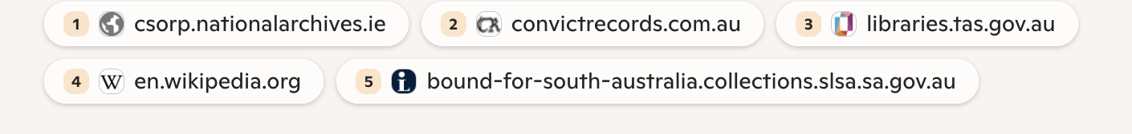

AI will engage with you by asking thoughtful questions and offering suggestions to help you maximize its potential.

15. Suggestions for book title, document, poster & family reunion
Remember you must tell AI about your project to achieve this, give as much information you can.
Me> Can you please suggest some titles for a book I'm writing about my g.g. grandfather George Smith who came out as a convict from Ireland to Van Diemen's Land in 1821 and his life in Australia
AI< That sounds like an incredible project, Maureen! Since you're focusing on George Smith’s journey from Ireland to Van Diemen’s Land and his life in Australia, here are some possible book titles that might capture his story:
- Bound in Chains, Freed by Fate: The Journey of George Smith
- From Convict to Colonist: The Story of George Smith in Van Diemen’s Land
- Ireland to Exile: The Life and Legacy of George Smith
- Marked by the Tides: A Convict’s Tale from Van Diemen’s Land
- The Smith Chronicles: A Convict’s Journey to New Beginnings
- Van Diemen’s Legacy: George Smith and the Convict Era
- Sentenced to Survival: The Remarkable Life of George Smith
- Chains to Prosperity: The Van Diemen’s Land Story of George Smith
- Convict No. [Insert His ID]: A Life Reclaimed in Australia
- Echoes of Exile: The Convict Odyssey of George Smith
AI< Would you like me to refine these further based on any specific themes you’re focusing on, such as his profession, family life, or contributions to early colonial society? Let me know how I can help fine-tune the title to suit your vision!
Me> Please design me an A3 poster with cream background, green tree and the following information: Smith Family Reunion, at the City Park Launceston, date 01 January 2030 starting at 10am and finished at 5pm. BYO picnic lunch. Please bring along photos & documents about your ancestor.
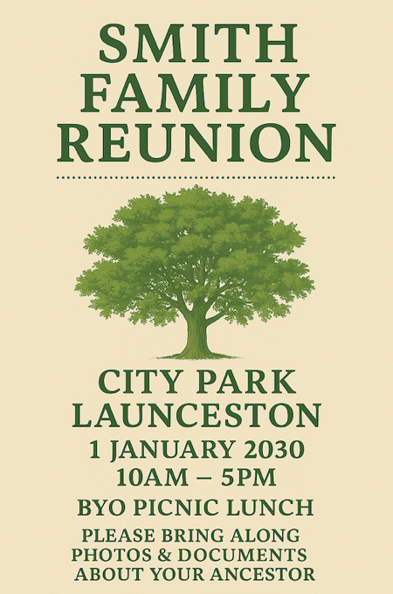 | 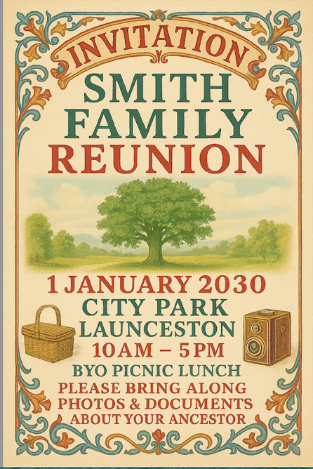
Your design offers limitless possibilities, allowing you to incorporate any information, colours, & elements you desire. Also asked to design an elaborate invitation with graphics to the family reunion.
16. YouTube videos AI and Genealogy Research
There are several YouTube videos out there that can explain how to use AI with your family history research, here are but a few.

* Beginning with AI Genealogy:
getting started with generative artificial intelligence in 2025
https://www.youtube.com/watch?v=rYWEl6OSIBE
* The 3 Free AI tools I use for genealogy
https://www.youtube.com/watch?v=Q8oJTK3sDB0
* What it Can Do & What it Can’t
https://www.youtube.com/watch?v=ZM4lE4fz2I8
* ChatGPT for Genealogy (with accuracy) here’s how
https://www.youtube.com/watch?v=LnBKjprPTPo&t=334s
* Craft perfect AI Prompts for Genealogy:
The 4-part framework that gets results
https://www.youtube.com/watch?v=0YD-ZAEe5-w
* Can AI build your Family Tree and Identify ancestors you missed?
https://www.youtube.com/watch?v=1gAbonFi2NY
*When AI and Genealogy Unite
https://www.youtube.com/watch?v=HW4Gsj5fe5k

